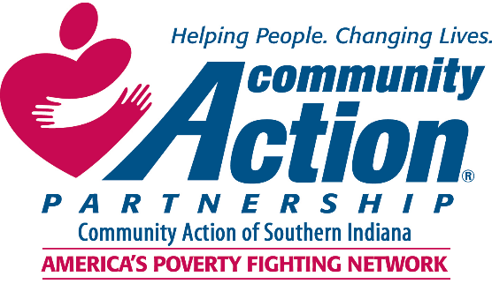

2023 Community Needs Assessment
Introduction 2
About Community Action of Southern Indiana (CASI) 2
Service Area 3
Direct Service Statistics 2022 3
Overview of the Causes and Conditions of Poverty 4
What is Poverty? 4
How is Poverty Measured? 4
Understanding the Causes and Conditions of Poverty 5
Methodology 7
Client Survey 7
Secondary Data 7
Service Area Demographics & Poverty Statistics 8
Population 8
Poverty 9
Community Needs 10
Client Survey Participants 10
Top Community Needs 11
Quality and Affordable Housing 11
Assistance with Legal Services 13
Good Jobs with Adequate Wages, Benefits, and Opportunities 14
Counseling Services 16
Budgeting Classes and/or Credit Counseling/Repair 17
Additional Community Needs 18
Methods of Dissemination 19
Final Thoughts 19
Appendix 1: Client Survey Questions 20
Appendix 2: References 20

Introduction
Community Action Agencies throughout the country are required to conduct a community needs assessment every three years. This needs assessment relies on relevant and current research literature, data from client surveys and community partner surveys, as well as data from the U.S. Census Bureau and Bureau of Labor Statistics. This community needs assessment is intended to guide Community Action of Southern Indiana (CASI) in developing its strategic plan to improve the economic security and well-being of low-income Hoosiers in its service area.

About Community Action of Southern Indiana (CASI)
For 57 years, Community Action of Southern Indiana has been providing a comprehensive approach to addressing the needs of vulnerable citizens while helping them to achieve economic security. Community Action of Southern Indiana’s programs provide critical support in areas such as financial literacy, education, housing, literacy, energy assistance, and more. Southern Hoosiers, like many Americans, face an array of enormous challenges ranging from poverty to disability to lack of decent and affordable housing to lack of adequate employment.
Community Action Agencies were created by the federal government in 1964 to combat poverty in geographically designated areas. Status as a Community Action Agency is the result of an explicit designation by local or state government. Community Action Agencies seek to involve the community, including elected public officials, private sector representatives, and especially low-income residents, in assessing local needs and attacking the causes and conditions of poverty.
In order to reduce poverty in our community, Community Action of Southern Indiana works to better focus available local, state, federal, and private resources to assist low-income individuals and families to acquire useful skills and knowledge, to gain access to new opportunities, and to achieve economic self-sufficiency.
Community Action of Southern Indiana’s broad base of services makes a difference every day for individuals and families.

Service Area
CASI serves Hoosiers in Clark, Floyd, and Harrison counties.
Current program offerings include:
- Minority Health Initiative
- Teen Boutique
- Tobacco Prevention
- Weatherization
- VOICE Action Speaks
- Volunteer Income Tax Assistance (VITA)
- Youth Success

- Black L.O.V.E.
- Community Gardens
- Empower Southern Indiana
- Head Start and Early Head Start
- Housing Choice Voucher
- Individual Development Accounts
- Life Literacy Academy
- Learning Center

Direct Service Statistics 2022
- Head Start and Early Head Start serve over 300 children, newborn to 5 years old
- Over 50 families received weatherization services
- The Minority Health Initiative’s Back to School Health Fair served over 2,000 people in a day
- Dozens of low-income individuals got their tax returns done for free

Overview of the Causes and Conditions of Poverty
We strive to make our communities places in which all Hoosiers can meet their basic needs and achieve financial well-being, enabling each person to reach their full potential and better contribute to their families and communities. Although poverty has existed in every society, scholars, government leaders, and social service providers offer a wide variety of thoughts about how best to tackle this multi-faceted epidemic. By better understanding poverty, how it is measured, and the causes and conditions of it, Community Action Agencies and their partners will be better equipped to develop interventions that are responsive to community conditions.

What is Poverty?
“Poverty is hunger. Poverty is lack of shelter. Poverty is being sick and not being able to see a doctor. Poverty is not having access to school and not knowing how to read. Poverty is not having a job, is fear for the future, living one day at a time. Poverty has many faces, changing from place to place and across time, and has been described in many ways. Most often, poverty is a situation people want to escape.”
-The World Bank
Globally and here in the United States, there have been longstanding efforts to end poverty. In 1964, President Lyndon Johnson declared war on poverty in his State of the Union address, proclaiming, “Our aim is not only to relieve the symptom of poverty, but to cure it and, above all, to prevent it.” He launched an effort that resulted in the development of Community Action Agencies, which still carry forward the mission of ending poverty and promoting community development today. Sargent Shriver, who led the development of solutions, described the War on Poverty as “a means of making life available for any and all pursuers. The War on Poverty tries only to create the conditions by which the good life can be lived."

How is Poverty Measured?
In the United States, poverty is measured by comparing a person’s or family’s income to a poverty threshold. This threshold is set at three times the cost of a minimum food diet in 1963, adjusted for inflation, and is responsive to family size. The U.S. Census Bureau is the government agency in charge of measuring poverty. As Overlooked and Undercounted: Struggling to Make Ends Meet in Indiana shows, this method of measuring poverty fails to count many who struggle. When a county- and family-specific basic needs budget is compared to family incomes in Indiana, the scope of income inadequacy in our state comes into sharper focus and includes many more individuals than are captured in traditional poverty measures.

Understanding the Causes and Conditions of Poverty
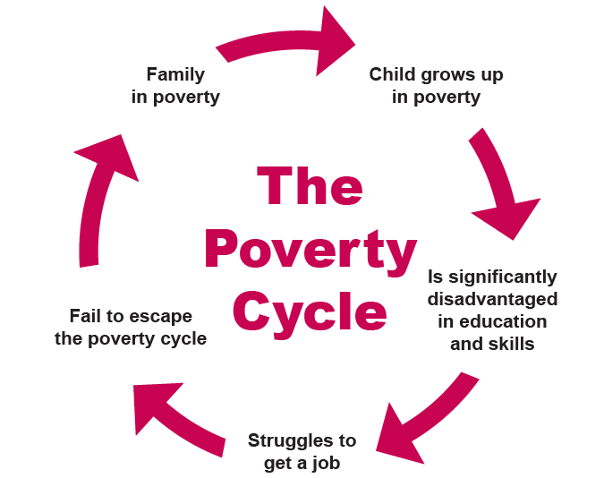
While poverty is, at its most simplistic level, a shortage of income, teasing apart the causes and associated conditions of these income shortfalls can be much more challenging and will vary based on local, state, and national policy choices as well as variations in communities, institutions, and individuals. Understanding the causes and conditions can assist in the development of effective solutions. Theories about the causes of poverty fall into three broad categories: political, structural, and behavioral. These focus attention on different sets of actors and interventions to address poverty. Community action agencies tend to work across all categories. Whether explicit or implicit, an individual‘s or organization’s theories about the causes of poverty can shape decision-making about approaches.
Because employment is so central to a household’s ability to make ends meet in the United States, job loss, a decline in earnings, a lack of education, a disability, and the presence of children and/or caregiving responsibilities can cause poverty. Lack of access to foundational resources such as transportation, child care, health care, and decent, affordable housing, as well as in interaction with the justice system, can also cause poverty. This can trap children and families in a cycle that is difficult to escape.
There are disparities in the prevalence of poverty by race, gender, ability, age, and other identities. Historic and ongoing discrimination at all levels of society - from policies that prevented Black families from accruing wealth through homeownership to discrimination in employment to differing expectations about who should provide care to young children - contribute to these disparities. In turn, poverty can lead to low education levels, lack of or under-employment, poor housing conditions, food insecurity, mental and physical health challenges, and an inability to access additional resources to live a happy and healthy life that show up disproportionately for certain groups.
Adding to this, the COVID-19 pandemic has had dramatic effects on our economy, public health, and perhaps most importantly our most precious asset, our children. It increased housing and food insecurity, reduced familial income, impacted children's school performance and mental health, and increased abuse and child maltreatment. School closures contributed to many of these factors as students were unable to access meals provided at school, social support systems, and a safe environment away from abusers. Brown University projected, based on learning patterns of five million students, that school-aged children in the United States learned less than 50% of math skills and less than 70% of language art skills than they would have acquired with in-person learning the previous spring. The Organization for Economic Cooperation and Development has estimated that school closures will result in approximately a 3% lower income for children affected by the closures over their entire lifetime, but it will be even more deeply felt by vulnerable children who will have larger learning losses, and therefore deeper losses in lifetime earnings. Remaining mindful of the new landscape and challenges COVID-19 created will be necessary in efforts to address poverty.
Finally, poverty leads to associated conditions that can compound the challenges of providing support to help individuals reach and maintain self-sufficiency. These include hunger, limited access to education and other services, discrimination, exclusion, and lack of opportunities for civic participation. Physiological effects such as toxic stress and poor physical health can create additional barriers. Evidence suggests that these can be particularly damaging for young children, as they impact brain development and cognitive function. Addressing these conditions – as well as the root causes of poverty – are critical to achieving widespread
well-being.

Community Action Agencies can:
- Engage staff and community members in reflection on assumptions about the causes and conditions of poverty
- Ensure that all individuals receive fair and equitable treatment through ongoing internal and external evaluation
- Be responsive to disparities in poverty through programming selection
- Collect data on the causes and conditions of poverty in their service area

Methodology

Client Survey
Between January and May 2023, the Indiana Community Action Poverty Institute created and fielded a client survey using SurveyMonkey for CASI. The client survey consisted of 53 questions that were reviewed by CASI staff and revised according to their needs. The survey link was sent by email to clients of CASI in April of 2023 and was active until May 2023. The survey consisted of multiple choice and open-ended questions. Two hundred thirty-four clients completed the survey over this time.

During the data analysis process, incomplete surveys were filtered out and not included in the findings. The completeness of the survey was determined by participants finishing the entire survey, not answering every question. Due to respondents not having to answer all the questions, some tables will not include all participants. The survey team utilized SurveyMonkey analysis software to analyze multiple choice survey questions. Open-ended survey questions were exported to Excel for further analysis.

Secondary Data
While a primary focus of the community needs assessment is elevating the voices and expressed needs of low-income Hoosiers, secondary data drawn from the U.S. Census Bureau's American Community Survey and other national surveys provide valuable supplemental information about the service area throughout the report. The American Community Survey is conducted yearly and sent to a sample of approximately 3.5 million addresses in the 50 states, District of Columbia, and Puerto Rico. It asks about a range of topics, including education, employment, internet access, and transportation and typically achieves a high response rate (85.3% in 2021). Local, state, and national leaders depend on the American Community Survey to understand local issues, develop programs, and distribute funding. These secondary data are intended to help speak to the scope of needs facing local communities and thereby assist in strategic planning.

Service Area Demographics & Poverty Statistics
Demographic data offer a snapshot of who lives in particular communities at a given time and can provide a basis for understanding the needs of a community. For example, communities with a large proportion of older Hoosiers may require more services related to aging while those whose communities vary greatly on ethnicity and primary language data may require more translation and interpretation services.

Population
 | Service Area | Clark | Floyd | Harrison
Population | 235,394 | 118,378 | 77,992 | 39,024
Under 5 years | 13,768 | 7,193 | 4,432 | 2,143
5 to 17 years | 39,150 | 19,312 | 13,326 | 6,512
18 to 34 years | 48,966 | 25,631 | 16,197 | 7,138
35 to 64 years | 96,064 | 47,743 | 31,887 | 16,434
65 years and over | 37,446 | 18,499 | 12,150 | 6,797
Male | 115,429 | 57,952 | 38,008 | 19,469
Female | 119,965 | 60,426 | 39,984 | 19,555
White alone | 208,718 | 102,020 | 69,311 | 37,387
Black or African American alone | 11,773 | 7,748 | 3,811 | 214
American Indian and Alaska Native alone | 316 | 232 | 84 | 0
Asian alone | 2,309 | 1,137 | 958 | 214
Native Hawaiian and Other Pacific Islander alone | 24 | 15 | 9 | 0
Some other race alone | 2,562 | 1,579 | 556 | 427
Two or more races | 9,692 | 5,647 | 3,263 | 782
Hispanic or Latino origin  (of any race) | 10,388 | 6,774 | 2,802 | 812
Source: U.S. Census Bureau, 2017-2021 American Community Survey 5-Year Estimates

Poverty
Across the counties CASI serves, approximately 22,475 Hoosiers experienced poverty (9.5%), a smaller percentage than the state as a whole (12.5%). These Hoosiers were more likely to be female, age 35-64, and White. At the same time, a higher proportion of children under 5 (14.0%), children age 5 to 17 (13.3%), individuals age 18 to 34 (10.4%), Black (26.8%). American Indian / Alaska Native (10.8%), Other Race (15.0%), Two or More Races (16.5%), and Hispanic/Latino (21.8%) Hoosiers in the service area experienced poverty.
 | Number in Poverty |  | % in Poverty |  | State % in Poverty
Total Population | 22,475 |  | 9.5% |  | 12.5%
Male | 9,692 |  | 8.4% |  | 11.2%
Female | 12,783 |  | 10.7% |  | 13.7%
Under 5 | 1,927 |  | 14.0% |  | 19.2%
5 to 17 | 5,221 |  | 13.3% |  | 16.0%
18 to 34 | 5,111 |  | 10.4% |  | 16.1%
35 to 64 | 7,540 |  | 7.8% |  | 9.8%
65+ | 2,676 |  | 7.1% |  | 7.7%
White | 17,126 |  | 8.2% |  | 10.3%
Black | 3,153 |  | 26.8% |  | 25.8%
American Indian /  Alaska Native | 34 |  | 10.8% |  | 20.2%
Asian | 179 |  | 7.8% |  | 14.7%
Native Hawaiian /  Pacific Islander | 0 |  | -- |  | 14.7%
Other | 385 |  | 15.0% |  | 21.2%
Two or More Races | 1,598 |  | 16.5% |  | 18.1%
Hispanic / Latino² | 2,260 |  | 21.8% |  | 19.4%
Source: U.S. Census Bureau, 2017-2021 American Community Survey 5-Year Estimates

Community Needs
Local governments, community programs, and advocates are constantly working to understand the needs of their residents. This is particularly important in light of the disruptions caused by the COVID-19 pandemic. Knowing what needs are most important to residents can ensure that community members are able to live happy, healthy, and productive lives. Our primary method of establishing needs was through direct consultation with low-income Hoosiers in the service area. We used a client survey to ask respondents to identify three services that would improve their lives (blank entry) and to rank their top five unmet needs from a pre-established list of 20 common needs. The blank entry allowed us to capture needs not represented in the list and to represent Hoosiers’ needs in their own words. For each identified need, a selection of the respondents’ own words are used to explain the perceived need, while research studies and secondary data provide additional perspective on the need’s relationship to poverty.

Client Survey Participants
Survey participants were from Clark (51.3%), Floyd (34.2%), and Harrison (14.5%) Counties.
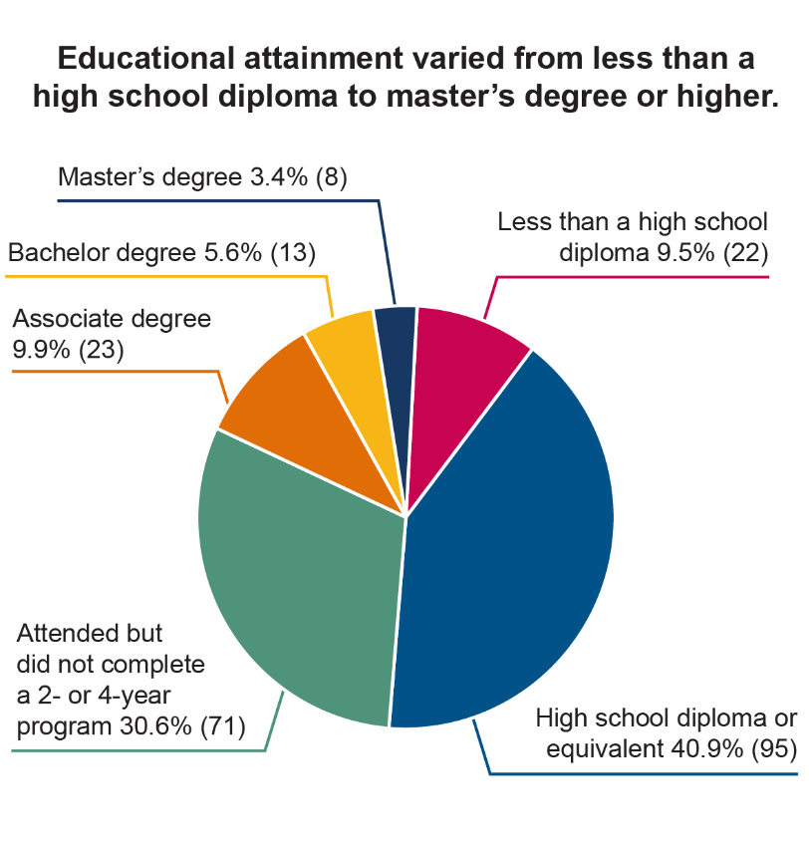
Among survey respondents:
- The majority were either age 35-49 (30.5%) or age 50-64 (33.5%), while 18.0% were age 18-24 and 18.0% were age 65+
- 86.2% identified as female and 13.4% as male
- 79.1% of identified as White, 16.7% as Black, and 2.6% as American Indian or Alaskan Native. .
- 3.0% were Hispanic or Latinx
- 51.3% of survey participants stated that there are children who live in their household at least part-time, and 19.7% stated that the children in their household are either their grandchildren or the children of a family member.
- 32.1% of those who answered the question about hunger reported that someone in their household went hungry at least one day each week.
- 69.7% of survey participants reported that a member of their family had a disability.

Top Community Needs
The following are the top needs as identified by clients, as well as the top five from CASI’s 2020 community needs assessment. The clients’ top five identified needs are discussed in depth below.
Comparison of the Top 5 Needs Identified on Current and Previous Surveys
 | 2023 Client Needs | 2020 CNA
1 | Quality and affordable housing | Good jobs with adequate wages, benefits,  and opportunities
2 | Assistance with legal services | Programs and activities for youth
3 | Good jobs with adequate wages, benefits, and opportunities | Assistance with legal services
4 | Counseling services | Addiction treatment services
5 | Budgeting classes and/or credit counseling/repair | Quality and affordable housing

Quality and Affordable Housing

“Utility assistance, rental assistance.”
In clients’ own words:

“Lower utility bills or for the EPA to give more towards electric then gas (yes we heat by gas but its runs 25.00 a month to electric 150 a month).”
“Replacement of windows in our house. Help with replacing air conditioning unit. Putting covers on gutters.”

“Rental assistance or vouchers.”

“I need emergency housing from where I live. My life is in danger here.”

“Rent utilities.”

“Roof replacement assistance.”
“Affordable housing, lower utilities”

“Weatherization.”

Poor housing quality and lack of stable housing can be both a cause and condition of poverty. Researchers find that low-cost, decent quality housing in areas with job opportunities can make a significant difference in addressing poverty. Conversely, poor-quality housing can lead to poor health outcomes, causing poverty. Weatherization is a strategy for addressing housing quality that also contributes to reduced utility costs, improving a household’s financial position.

The U.S. Census Bureau asks Hoosiers about housing quality and affordability as part of the American Community Survey. Table 1 shows the estimated number of housing units in the service area and the percent that have one or more of following conditions: 1) lacking complete plumbing facilities, 2) lacking complete kitchen facilities, 3) with 1.01 or more occupants per room, 4) selected monthly owners costs as a percentage of household income greater than 30 percent, and 5) gross rent as a percentage of household income greater than 30 percent.
Table 1. Percent of Units with Poor Housing Affordability/Quality Conditions in CASI’s Service Area
Owner-Occupied Units: | 68,572
% Owner-Occupied Units with One or More Condition: | 14%
Renter-Occupied Units: | 22,419
% Renter-Occupied Units with One or More Condition: | 41%
Source: U.S. Census Bureau, 2017-2021 American Community Survey 5-Year Estimates
Fair Market Rents are estimates of the 40th percentile gross rents for standard quality units within an area. Spending more than 30% of income on rent is considered being ‘cost-burdened.’ In Table 2 below, the 2023 FMRs for the service area and minimum household income required to avoid being cost burdened are provided.
Table 2. Fair Market Rents and Required Income to Avoid Cost Burden
 | One  Bedroom | Income Required | Two  Bedroom | Income Required
Clark-Floyd-Harrison | $876 | $2,920 | $1,052 | $3,507
Source: U.S. Department of Housing and Urban Development 2023 FMR

Community Action Agencies can:
- Provide weatherization and other housing quality improvement services
- Invest in or collaborate to create affordable housing options
- Connect Hoosiers in need with Housing Choice Vouchers and other housing stabilization or homeownership programs

Assistance with Legal Services
In clients’ own words:
“Help with taxes and owing.”

“Legal help (divorce child custody stuff).”

“Child support.”

The federal government recognized the importance of legal services to poverty reduction and began to fund civil legal aid as part of the War on Poverty in the 1960s. This support has yielded many benefits as cases brought by civil legal aid programs have increased rights for tenants, welfare recipients, consumers, and other low-income Americans. However, current funding for legal services in Indiana is insufficient to serve low-income Hoosiers seeking such aid. In a typical year, four out of five low-income families experience at least one civil legal problem. An estimated 30 percent of the cases for which households sought assistance - and an even greater proportion of the civil legal problems low-income households faced - were not served at all by Indiana’s legal aid system.

The top three legal areas in which unrepresented parties often appear are family issues (73.9%), consumer and finance issues (64.4%) and rental housing (52.0%). Given the complexity of civil matters, unrepresented parties receive worse outcomes than people who receive counsel; unrepresented parties were never or rarely successful in legal issues and are estimated to have a fail rate of 65.9% in disability cases, 57.6% in employment cases, 57.6% in veterans' affairs cases, and 49.4% in medical services cases. Representation matters.

Community Action Agencies can:
- Screen for legal needs and refer to appropriate resources
- Offer “Know Your Rights” sessions or materials
- Establish CAA-legal partnerships modeled after medical-legal partnerships that embed legal professionals in their organization.

Good Jobs with Adequate Wages, Benefits, and Opportunities
In clients’ own words:

“Assistance with starting a business, grants or loans.”
“Help with a good job that doesn't look at background, and has a great flexible schedule if needed.”

“Help with getting a job that I like.”
“Find extra side jobs, small business.”

“A trade.”

Addressing unemployment, underemployment, and low-wage work through pathways to high-wage jobs is a key mechanism to address poverty. Paid employment is the primary mechanism through which individuals in the U.S. receive income. Unfortunately, pre-Covid, 44% of the workforce worked in low-wage jobs, earning at or below 200% of the federal poverty threshold. While some workers in low-wage or unstable jobs adopt a second job or “side hustle” to help make ends meet, these added hours can be unsustainable, especially for families with caregiving responsibilities. Table 3 shows the most common occupations for the Southern Indiana Non-Metropolitan Area and Table 4 shows the most common occupations for the Louisville Metropolitan Area.
Table 3. Most Common Occupations in Southern Indiana Nonmetropolitan Area
Occupation | Estimated  Number Employed | Median  Hourly Wage
Misc. Assemblers and Fabricators | 11,590 | $19.53
Heavy and Tractor-Trailer  Truck Drivers | 5,110 | $23.52
Fast Food and Counter Workers | 4,750 | $10.91
Laborers and Freight, Stock,  and Material Movers | 4,660 | $16.83
Cashiers | 4,630 | $11.25
Source: U.S. Bureau of Labor Statistics OES May 2022
Table 4. Most Common Occupations in Louisville Metropolitan Area
Occupation | Estimated  Number Employed | Median  Hourly Wage
Laborers and Freight, Stock, and Material Movers | 28,190 | $19.41
Misc. Assemblers and Fabricators | 21,110 | $21.60
Stockers and Order Fillers | 16,130 | $17.59
Registered Nurses | 15,560 | $38.05
Retail Salespersons | 15,280 | $13.58
Source: U.S. Bureau of Labor Statistics OES May 2022

Job search supports and other supportive services such as stabilizing housing and providing childcare and transportation are essential to creating pathways to good jobs. Preserving attachment to the workforce also requires addressing mental and physical health, as concentration and productivity can be affected by health concerns, and the social stigma of mental illness may further worsen employment prospects or outcomes. Survey respondents listed childcare issues, inability to find jobs with adequate wages, flexibility needed to attend appointments, and criminal history as among the reasons they were not working or were only working part time.
Helping workers think beyond wages to the benefits they will need to maintain employment and financial stability may also prove productive. For example, new parents can experience large income gaps around the birth of a child while lack of health insurance coverage or underinsurance can lead to medical debt. Attending to benefits like health insurance, paid leave, and savings options can insulate families from falling back into poverty in the future.
Lacking the skills necessary for certain types of employment may also be a barrier, as 83% of businesses in Indiana report that they are struggling to fill open positions, with 48% reporting that applicants lack the skills and qualifications they need. Among individuals in poverty in Hoosier Uplands’ service area, the U.S. Census Bureau estimates that approximately two-thirds have a high school degree or less. Figure 1 represents the estimated breakdown of educational attainment among individuals in poverty in the service area.

Figure 1. Educational Attainment of Individuals in Poverty in CASI’s Service Area
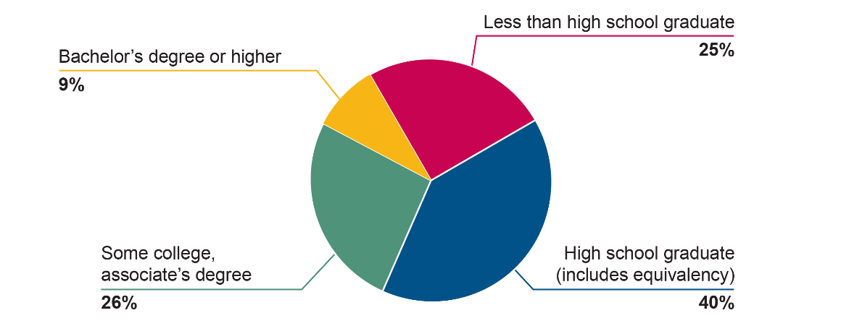
Source: U.S. Census Bureau, 2017-2021 American Community Survey 5-Year Estimates
Community Action Agencies can:
- Connect individuals with job search and application services
- Use the self-sufficiency standard calculator or other tools to help individuals understand what wage will be needed to meet self-sufficiency
- Help individuals plan for benefit cliffs as they move into higher-wage jobs or receive promotions
- Connect individuals to education and training programs that will support their entry into higher wage jobs
- Serve as a model employer in their community
- Offer services that support the employment of working-age adults, such as child care and access to transportation

Counseling Services
In clients’ own words:

“Therapy sessions.”
“Due to my health conditions, I cannot keep up with my household duties which causes severe depression.”

“Therapist.”

“Counseling services for my kids.”

Mental and physical health conditions are both a cause and condition of poverty. There are vicious cycles at work that allow people to continually stay in poverty and ultimately produce intergenerational effects related to a person’s mental and physical health. Those experiencing low income or poverty are one and a half to three times more likely to experience depression or anxiety. A loss in income can produce stress and anxiety for a person and their household, while mental illness can also worsen economic outcomes. The effects of depression and anxiety such as loss of attention span and a distorted memory are likely to influence a person’s economic decisions regarding their work and consumption habits.
Interventions to address mental and physical health and poverty must be complementary in order to make progress. In order to be economically productive, mental equilibrium is essential. On a positive note, interventions such as cash transfers and broader antipoverty programs have been shown to reduce depression and anxiety in randomized trials.^{i}

Community Action Agencies can:
- Connect with, co-locate, or offer health services to ensure that clients can receive treatment for physical and mental health
- Embed screening and referral systems for physical and mental health in other client services
- Equip frontline staff to be responsive to physical or mental health needs

Budgeting Classes and/or Credit Counseling/Repair
In clients’ own words:
“Maybe some credit/ debt help, finding a car, help on being able to buy a home.”

“Services that help young teens learn about money, savings, and budgeting.”

Credit reporting agencies (CRAs) or “credit bureaus” collect and use data to rate consumers’ “creditworthiness.” These reports and scores have far-reaching implications for Hoosiers’ lives; they not only factor into who can get a loan and on what terms, but they can also affect insurance coverage and costs, job opportunities, housing, and other basic services. Accordingly, there has been significant interest in how scores are developed, how to improve their accuracy, and how to help individuals with impaired or non-existent scores.^{xxvii}

Community Action Agencies can:
- Provide budgeting and credit counseling programs, such as Your Money, Your Goals
- Partner with financial institutions to offer credit building products or services
- Provide debt relief to assist in removing collections from individuals’ credit reports

Additional Community Needs
In response to the open-ended question, participants also expressed a variety of other needs, including:

Transportation
“Gas vouchers. They are breaking us.” “Public transportation” “Gas for cars.” “Would love to have a program that helps with cost of vehicle like insurance.” “Transportation.” “Cheaper car insurance.” “Gas card.” “Car maintenance, help with gas, car insurance…At least until I am secure in a job that I can then get back & forth to.” “Some form of transportation because the buses don't go far or run on very good hours.” “Vehicle repairs.” “Crisis assistance for car repairs.” “A service to take people to the stores where they shop and just let people get out during the day.”
Food Security
“Meals on Wheels.” “More food stamps.” “Groceries.” “Food help.” “Cheaper groceries.” “More food stamps. I only get $23 a month.”
Connectivity
“Internet payments.” “Free internet.”
Child Care
“Daycare/after school care.” “Childcare, childcare, childcare.”
Education / Student Debt Relief
“Help with college.” “Help with education cost.” “Student loan forgiveness.”
Health Care / Medical Debt Relief
“Health insurance.” “Dental assistance, vision coverage, veterinary assistance.” “Free medication delivery.” “Help for medical things not covered by insurance but needed.” “Primary care to do home visits including blood tests.”
Family Assistance and Programs
“Some kind of buddy system where somebody calls the house least twice a week and make sure they just talk to somebody for a minute and I would like to have a wrist alarm in case I would fall outside.” “Big Brother Big Sister Program.” “Family Development and Crisis Program.”

Methods of Dissemination
The needs assessment serves as a guide for CASI to leverage new funding sources, recognize the impact of the services they provide, and understand how they can improve their agency. The results of the evaluation will be disseminated on CASI’s website and social media.

Final Thoughts
The top identified needs will require resources and interventions at the family, agency, and community levels.

Community Action Agencies are leaders in the complex and ever-changing work of addressing the causes and conditions of poverty in Indiana. Through deep understanding of the contexts in which Hoosiers are born, grow up, work, and raise families, they innovate, adapt, and serve. When Hoosiers are financially stable, they can reach their full potential and better serve their families and communities. All Hoosiers owe a debt to these agencies as they continue to fight on the front lines of the War on Poverty.

Appendix 1: Client Survey Questions
Question 1:
What county do you live in?
Zip Code
What is your age group?
[18-24] [25-34] [35-49] [50-64] [65-69] [70+]
What is your gender?
[Male] [Female] [Non-Binary] [Prefer not to say]
What is your race/ethnicity? Check all that apply.
[White]
[Black]
[American Indian or Alaskan Native]
[Asian American or Pacific Islander]
[Hispanic or Latinx]
[Prefer not to say]
[Other (please specify)]
What languages are spoken in your home: Check all that apply.
[English] [Spanish] [French] [Portuguese] [American Sign Language] [Haitian Creole] [Arabic]
[Burnese] [Chinese] [Farsi] [Korean] [Kurdish] [Somali] [Tagalog] [Vietnamese]
[Other (please specify)]
What is your household status?
[Single] [Married] [Partner] [Living with roomate/s]
How many adults – including yourself – are in your household?
Are there children who live in your household at least part of the time?
[Yes] [No]
How many children, by age, are in your household?
Are any of the children in your household your grandchildren or the children of another family member?
[Yes] [No]
Are you eligible to receive child support for the children in your household?
[Yes] [No]
Choose the statement that BEST describes your child support situation:
[We receive it regularly for all eligible children]
[We receive it regularly for some but not all the children]
[We receive it sometimes but not regularly]
[We do not receive it but have attempted to receive it]
[We do not receive it and do not want to pursue it]
[Other (please specify)]
Which of the following best describes your access to childcare?
[Childcare is provided by a family member or friend]
[Children not enrolled in childcare]
[Children on a waitlist for enrollment in childcare]
[Child enrolled in childcare voucher program for care at a home-based, center or ministry]
[Child enrolled in childcare that we pay for completely]
[Children are old enough/capable to care for themselves]
[Other (Please specify)]

Which of the following BEST describes the reason that your children are not enrolled in childcare (a licensed home, a center, or a ministry)?
[We prefer for our children to be cared for by family or friends]
[We can’t afford childcare]
[We can’t find childcare near our home or work]
[We can’t find childcare for the hours we need it]
[We can’t find childcare to support our child’s/children’s special needs]
[Other (please specify)]
What is the MONTHLY income of all household members combined? (Please use whole numbers only.)
What is your employment status?
[Unemployed, looking for work]
[Unemployed, not looking for work]
[Employed, work part-time]
[Work full time at one job]
[Work more than one job]
[Retired]
[Stay-at-home caregiver]
Which of the following statements best describes why you are struggling to find employment?
[Can’t find the hours/schedule I’m looking for]
[Do not have the skills I need to get the job I want]
[Can’t find the wage I need to get by]
[Can’t find a job because of prior criminal history]
[Other (please specify)]
Which of the following statements best describes why you are working part-time?
[Can’t get enough hours]
[Want to work part time]
[Other (please specify)]
Why do you prefer to work part time?
What is your highest level of education:
[Less than a high school diploma]
[High school diploma or equivalent]
[Have attended college or university in a 2 or 4 year program but didn’t finish it]
[Associate’s Degree]
[Bachelor’s Degree]
[Master’s degree or higher]
What is your experience with training certificates or licensing programs?
[Have never done a training program]
[Have attended a training program but did not finish it]
[Participated in an on-the-job training program at my work, but it did not include a certificate]
[Have a certificate or license from a specific job training program]
Which public and/or charitable programs do you and your families receive support from? (Check all that apply)
[Temporary Assistance for Needy Families (TANF)]
[SNAP (formerly Food Stamps)]
[Women, Infants, and Children Nutrition Program (WIC)]
[Free or Reduced School Lunch]
[Housing Choice Voucher (Section 8)]
[Emergency Rental Assistance]
[Medicaid]
[Children’s Health Insurance Program]
[Affordable Care Act Subsidies]
[Child Tax Credit]
[Earned Income Tax Credits]
[Child Care Vouchers/ CCDF/ On-My-Way-PreK]
[Food Banks]
[Free Health Clinics]
[Other (please specify)]
Which of the following services have you received from CASI?
[Multiple Choice Program Specific Services]
[None of the above]
[Other (please specify)]
How many days a week are you or someone in your household experiencing hunger?
Please rank the following bills from MOST LIKELY to delay paying if you are struggling to make ends meet to least likely to delay paying?
[Rent/Mortgage]
[Car Insurance]
[Utility bill (gas, electric, propane)]
[Child Care]
[Health Insurance]
[Groceries]
[Gas for Car]
[Child support payments]
[Medical expenses]
What THREE services would make your life better?
What are your TOP 5 unmet needs? (Choose only 5)
[A place to go to get help with applying for Social Security, SSDI, WIC, TANF, etc.]
[Assistance with legal services (e.g. family law, evictions, expungement, debt collection)]
[Counselors who work with families toward self sufficiency]
[Neighborhood clean-up projects]
[Crime awareness / crime reduction]
[Assistance with fines & fees]
[Good job with higher wages & benefits and/or opportunities to advance]
[GED classes]
[English as a second language classes]
[Computer skills training / job skills training]
[Help with job search & applications]
[Budgeting classes and/or credit counseling/repair]
[Parenting classes and/or classes on healthy relationships]
[Nutrition education / healthy eating workshops]
[Counseling services]
[Programs and activities for youth]
[Programs and activities for seniors]
[Help with home health problems, like mold or lead]
[Help to make homes more energy efficient (weatherization)]
[Addiction treatment services]
[Second-chance hiring programs for those with criminal records]
[Help to make housing more affordable (e.g. rental assistance, housing voucher)]
Do you have health insurance?
[Insurance through my employer]
[Insurance through a marketplace plan / plan I purchased for myself]
[Medicare]
[Hoosier Healthwise /HIP /Medicaid]
[TRICARE or Health Care Provided by Dept. Of Veterans Affairs]
[No insurance]
[Other]
Have any of the following made it difficult to obtain insurance? (Check all that apply.)
[Cost]
[Lack of knowledge of available options]
[Not offered by my employer]
[None of the above]
[Other (please specify)]
Are any of these true for you or a member of your family?
[Deaf or have serious hearing difficulty]
[Blind or having serious difficulty seeing even when wearing glasses]
[A physical condition or disability that impedes daily activities]
[A developmental/mental/emotional condition that impedes daily activities]
[None of the above]

Question 9:
Which family members in your household are deaf or have serious hearing difficulty? (Check all that apply)
[You]
[Spouse]
[Child under 12]
[Child 12-17]
[Child over 18]
[Other family member who lives in the home]

Question 10:
Which family members in your household are blind or having serious difficulty seeing even when wearing glasses? (Check all that apply)
[You]
[Spouse]
[Child under 12]
[Child 12-17]
[Child over 18]
[Other family member who lives in the home]

Question 11:
Which family members in your household has a physical condition or disability that impedes daily activities? (Check all that apply)
[You]
[Spouse]
[Child under 12]
[Child 12-17]
[Child over 18]
[Other family member who lives in the home]

Question 12:
Which family members in your household has a physical condition or disability that impedes daily activities? (Check all that apply)
[You]
[Spouse]
[Child under 12]
[Child 12-17]
[Child over 18]
[Other family member who lives in the home]

Question 13:
Does anyone in your household have a drug/alcohol problem?
[Yes, someone in my household misuses drugs/alcohol and is not receiving treatment]
[Yes, someone in my household misues or has a dependence on drugs/alcohol but is receiving treatment]
[Someone in my household has misused or had a dependence to drugs/alcohol, received treatment, and is currently not using]
[No, no one in my household has an addiction to drugs/alcohol]
Which of the following best describes your access to transportation?
[No access to transportation]
[Use public transportation]
[Have a car, but can’t afford to maintain it]
[Have a car that I can afford and it is dependable]
Do you (and your spouse/partner, if applicable) have.... (Check all that apply)
[a checking account?]
[a savings account?]
[a credit card?]
[an account designated for retirement savings (like a 401k or IRA)?]
In the past 12 months, did you and/or your partner:
[Purchase a money order from a place other than a bank]
[Cash a check at a place other than a bank]
[Take out a payday loan or payday advance at a payday lending store]
[Take out a payday or personal installment loan online]
[Used a rent-to-own center to get furniture, electronics, etc...]
Are you behind on payments or in collections on any of your debts?
[Yes] [No]
Do you or anyone in your household have medical debt greater than $500?
[Yes] [No] [Other (please specify)]

Please describe the housing arrangement where you currently live.
[I am currently without housing]
[I rent my home]
[I own my home]
[Other (please specify)]

Question 14:
You responded that you are currently without housing. Which of these best describes your sheltering circumstances?
[I am currently in temporary housing (shelter, etc.)]
[Live with family or friends (not an owner or listed on the rental contract)]
[Living in a car]
[Living outside (unsheltered)]

Question 15:
You responded that you rent your home. Which of these best describes your renting arrangement?
[Rent a subsidized home, apartment or other housing unit]
[Rent an unsubsidized home, apartment or other housing unit]
[Other (please specify)]

Question 16:
How much is your rent per month? (Please use whole numbers only)
Are you currently behind on rent?
[Yes]
[No]

Question 17:
You responded that you own your home. Which of these best describes your home ownership status?
[Own a home with a mortgage or loan]
[Own a home free and clear (without a mortgage or loan)]
[Own a home on land contract or with a rent to own/lease to own agreement]
[Own a mobile home with or without a mortgage, and pay lot rent]
[Own a mobile home with or without a mortgage on land that I own]

Question 18:
How much is your mortgage payment? (Please use whole numbers only.)
Are you currently behind on mortgage payments?
[Yes] [No]

Question 19:
How much are the payments on your rent/lease to own agreement? (Please use whole numbers only)
Are you currently behind on these payments?
[Yes] [No]

Appendix 2: References

Kucklick, A. & Manzer, L. (2022). Overlooked and Undercounted: Struggling to Make Ends Meet in Indiana. Indiana Community Action Poverty Institute. https://iiwf.incap.org/reports
Brady, D. (2019). Theories of the Causes of Poverty. Annual Review of Sociology, 45, 155-175.
Thompson, M. N., & Dahling, J. J. (2019). Employment and poverty: Why work matters in understanding poverty. American Psychologist, 74(6), 673.
Hahn, H. & Simms, M. (2021). Poverty Results from Structural Barriers, Not Personal Choices. Safety Net Programs Should Reflect That Fact. Urban Institute. https://www.urban.org/urban-wire/poverty-results-structural-barriers-not-personal-choices-safety-net-programs-should-reflect-fact
Jojo, Z. (2018). Creating an environment for the restoration of dignity to disadvantaged mathematics foundation classrooms. Environment and Social Psychology, 3. 10.18063/esp.v3.i2.695.
Aliprantis, D. & Carroll, D. R. (). What is behind the persistence of the racial wealth gap? Federal Reserve Bank of Cleveland. https://www.clevelandfed.org/en/publications/economic-commentary/2019/ec-201903-what-is-behind-the-persistence-of-the-racial-wealth-gap
Macey, E. (2019). Wages, Wealth, and Poverty: Where Hoosier Women Stand and Ways Our State Can Close the Gaps. Indiana Community Action Poverty Institute. https://iiwf.incap.org/wage-and-wealth-gaps
Abrams, E. M., Greenhawt, M., Shaker, M., Pinto, A. D., Sinha, I., & Singer, A. (2022). The COVID-19 pandemic: Adverse effects on the social determinants of health in children and families. Annals of Allergy, Asthma & Immunology, 128(1), 19-25.
Hanushek, E. A., & Woessmann, L. (2020). The economic impacts of learning losses. Organisation for Economic Co-operation and Development. https://www.edworkingpapers.com/sites/default/files/Hanushek%2BWoessmann%202020%20OECD%20Education%20Working%20Paper%20No.%20225.pdf
United Nations (2023). Ending Poverty. https://www.un.org/en/global-issues/ending-poverty.
Blair, C. & Raver, C. C. (2018). Poverty, Stress, and Brain Development: New Directions for Prevention and Intervention. Acad Pediatr 16(3). https://www.ncbi.nlm.nih.gov/pmc/articles/PMC5765853/
Tunstall, R., Bevan, M., Bradshaw, J., Croucher, K., Duffy, S., Hunter, C., ... & Wilcox, S. (2013). The links between housing and poverty: an evidence review. York: Joseph Rowntree Foundation.
OASH (2023). Quality of Housing. https://health.gov/healthypeople/priority-areas/social-determinants-health/literature-summaries/quality-housing
^{iii} U.S. Department of Energy, Office of Energy Efficiency and Renewables (2018). Weatherization works. https://www.energy.gov/sites/prod/files/2018/03/f49/WAP-fact-sheet_final.pdf
U.S. Department of Housing and Urban Development (2023). Fair Market Rents. https://www.huduser.gov/portal/datasets/fmr.html
Quintanilla, V. D., & Thelin, R. (2019). Indiana Civil Legal Needs Study and Legal Aid System Scan. Indiana University Public Policy Institute, (19-C01).
Ibid.
Fuller, J. B., & Raman, M. (2022). Building from the bottom up. Harvard Business School. https://www.hbs.edu/managing-the-future-of-work/Documents/research/Building%20From%20The%20Bottom%20Up.pdf
Scott, J., Edwards, K., & Stanczyk, A. (2020). Moonlighting to the side hustle: The effect of working an extra job on household poverty for households with less formal education. Families in Society, 101(3), 324-339.
Ridley, M., Rao, G., Schilbach, F., & Patel, V. (2020). Poverty, depression, and anxiety: Causal evidence and mechanisms. Science, 370(6522), eaay0214.
Stanczyk, A. B. (2019). Does paid family leave improve household economic security following a birth? Evidence from California. Social Service Review, 93(2), 262-304
Indiana Community Action Poverty Institute (2022). Medical Debt in Indiana. https://institute.incap.org/medical-debt
Indiana Chamber of Commerce (2022). Annual workforce surveys. https://www.indianachamber.com/news-resources/studies-reports/education-workforce-development/
Ridley, M., Rao, G., Schilbach, F., & Patel, V. (2020). Poverty, depression, and anxiety: Causal evidence and mechanisms. Science, 370(6522), eaay0214.
Ibid.

